User Guide

**Environment Requirement:**

* **Python 3.9:**

Install it from the official Python website: <https://www.python.org/>

* **Package:**

Inside the system code folder, you will find a file named requirements.txt. Run the following command to install the required dependencies using pip:  
> **pip install -r requirements.txt**

The above command will install Flask, Flask-CORS, Flask-SocketIO, NumPy, Pandas, TensorFlow, scikit-learn, joblib, Spacy, NLTK, and Folium packages necessary for the system to run.

**Running the System:**

1. **Start the Flask Server:**

Run the following command to start the Flask server in the terminal or command prompt, navigate to the system code folder:

> **python service.py**

1. **Access our System:**

Once the Flask server is running, open your web browser. Enter the following URL to access the INNJOY Recommendation System:   
 [**http://localhost:8000/index**](http://localhost:8000/index)Then you can see our home page of the system.

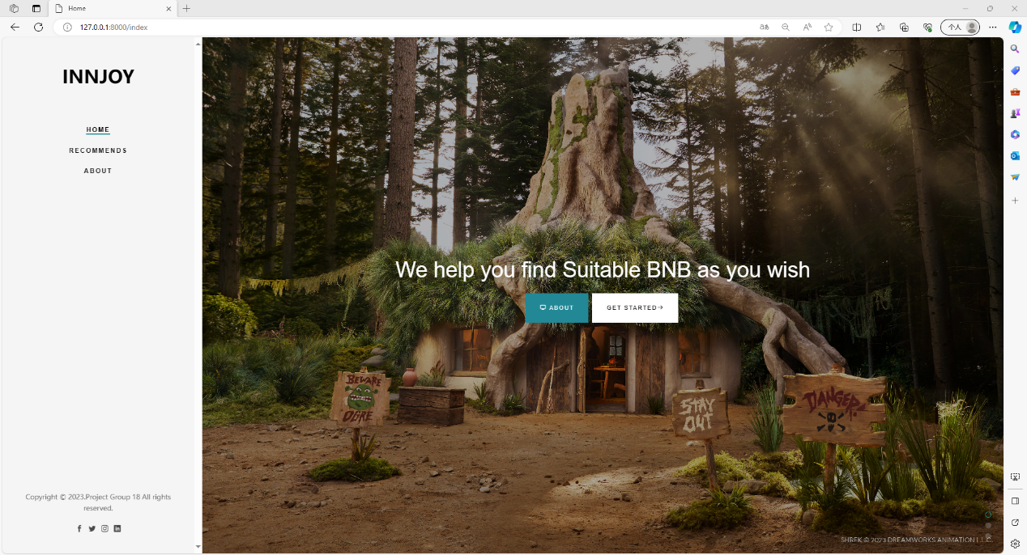

**Using our System:**

1. **Registration and Login:**

When you click Get started on the Home page, or click the Recommends tab on the left navigation bar, if you have not logged in recently, you will automatically jump to the Login & Sign up page.

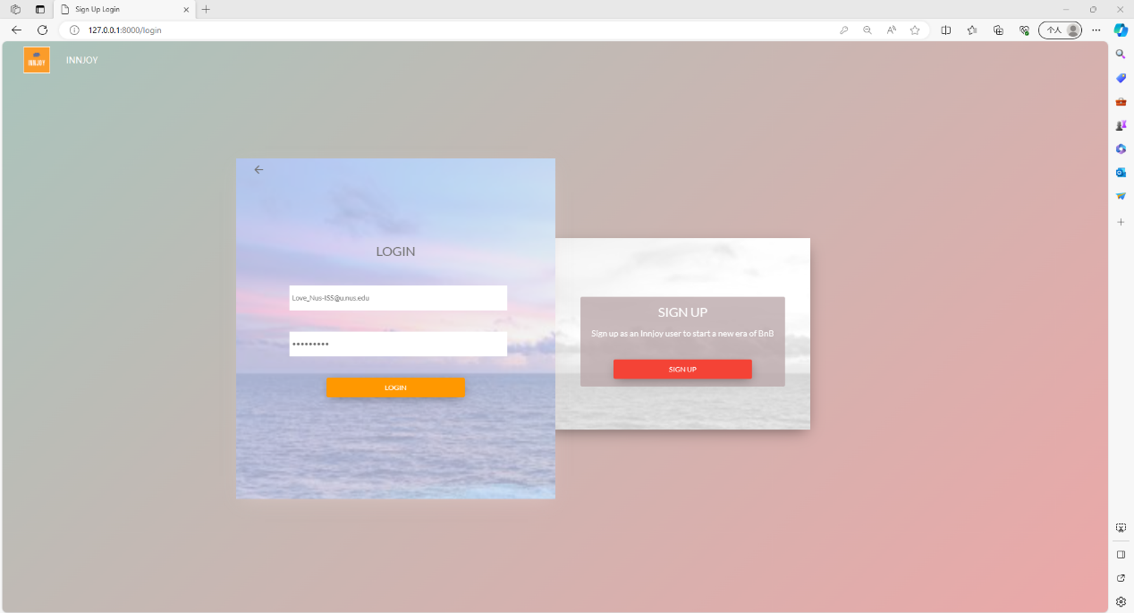

* If you are a new user, click on the "SIGN UP" button to create an account. Fill in the required details.
* If you are a returning user, click on the "LOGIN" button and enter your credentials to log in.

After logging in, you will be redirected to the Recommends page.

1. **Chatbot Interaction & Exploring Recommendations:**

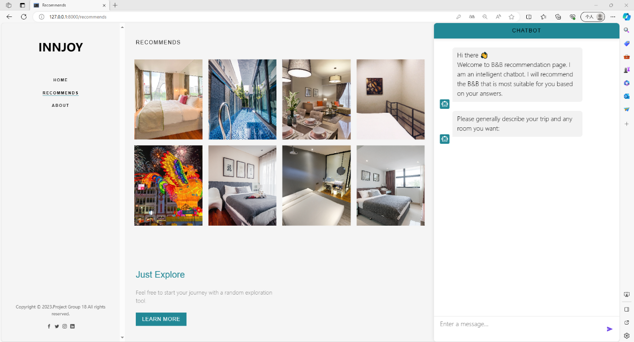

* When you first enter the page, the recommendation system will recommend 8 B&Bs that are more suitable for you based on their popularity scores and your historical orders.
* Use the chatbot interface to input your preferences and requirements for vacation rentals. The chatbot will guide you through the conversation, asking questions if necessary, to understand your preferences better.
* After each answer, the system will provide personalized recommended B&Bs based on your answer. You can click on the picture at any time to enter the B&B reservation page and view more detailed B&B information.

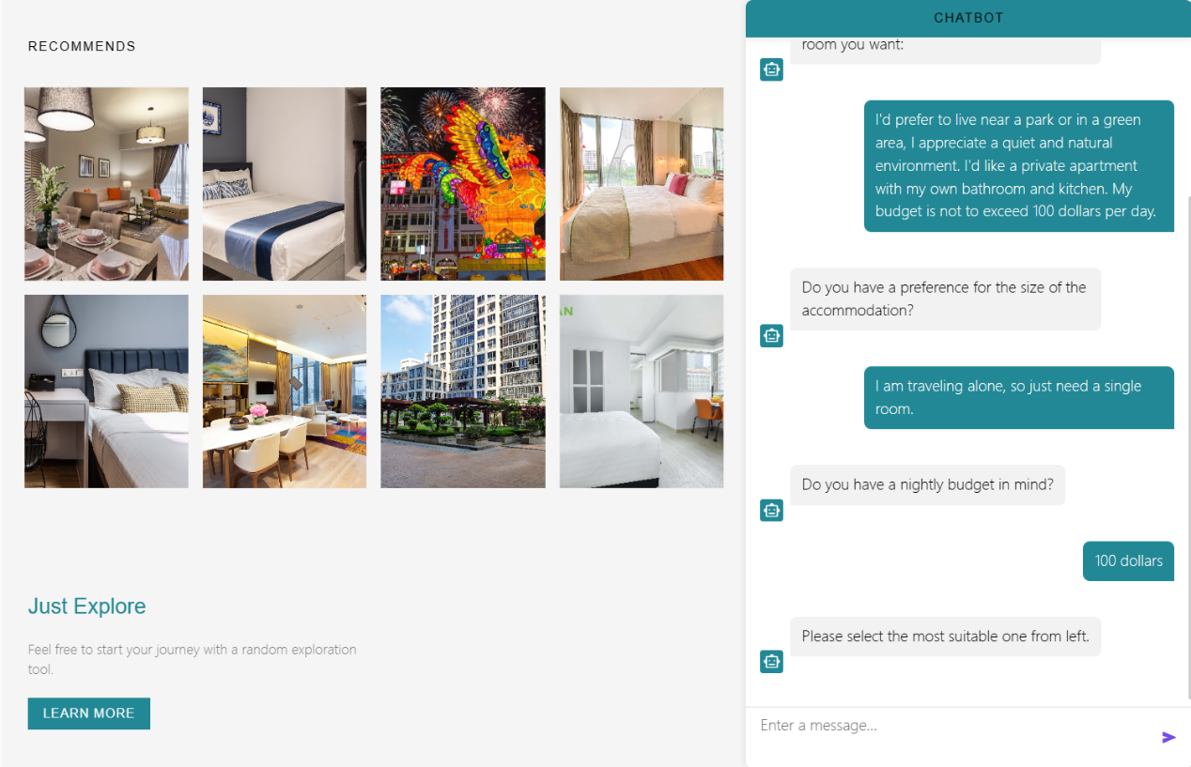

**Wish you a happy use!**